Prof. Dr. Seung-Mo Lee  Korea Institute of Machinery & Materials (KIMM) | 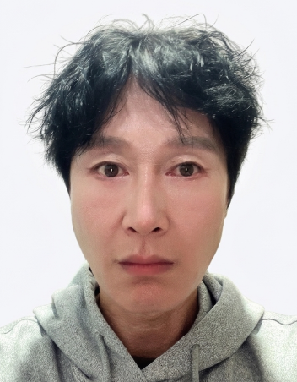

Prof. Dr. Seung-Mo Lee is a Principal Researcher at the Korea Institute of Machinery and Materials (KIMM) and a Full Professor in the Department of Nanomechatronics at the University of Science and Technology (UST), South Korea. He received his M.S. in Mechanical Engineering from Pohang University of Science and Technology (POSTECH) and his Ph.D. in Applied Physics from the University of Freiburg, Germany. During his doctoral and postdoctoral training at the Max Planck Institute for Microstructure Physics, he was among the first to apply atomic layer deposition (ALD) and its derivative, vapor phase infiltration (VPI), to natural materials, showing that infiltrating spider silk with metal oxides dramatically enhances its toughness (Science, 2009). He later served as a Visiting Professor at the Max Planck Institute for Colloids and Interfaces, Germany. At KIMM, he has extended ALD-based surface and interface engineering across a broad spectrum of functional materials, including thin films, carbon-based composites, secondary batteries, passive radiative cooling, and thermal management materials. His recent work focuses on bio-inspired surface engineering and sustainable composite materials for secondary batteries, solar energy harvesting, and next-generation thermal regulation. He has published extensively in leading international journals and is recognized for bridging fundamental materials science with practical engineering applications.

